Covid vignettes

**What would be problematic about the following research designs? How could they be improved?**

* In a vaccination trial, all volunteers are invited to visit their doctor. On arrival, some are randomly chosen to receive a vaccine, while others receive no treatment.
* During hospital treatment, patients with very severe Covid symptoms are given an experimental drug. Then their survival rate is compared with that of other ICU Covid patients.
* Researchers want to find out whether it is important to specifically target those who believe they have had Covid in public health messaging, to ensure that they continue to take precautions. To that end, people are surveyed and asked whether they believe they have had Covid in the past and whether they stick to Covid guidelines.
* What worry does this article reference raise (no need to look beyond it)?  
  Bae, S., Kim, M. C., Kim, J. Y., Cha, H. H., Lim, J. S., Jung, J., ... & Sung, M. (2020). Effectiveness of surgical and cotton masks in blocking SARS–CoV-2: a controlled comparison in 4 patients. *Annals of Internal Medicine.*

**What would be problematic about the following claim?**

* **2.8% of Covid cases are transmitted in gyms** – based on the following data:

*“The only government data on gyms comes from Public Health England's surveillance report, which is based on data from Test and Trace.*

*That data puts gyms on 2.8%, while supermarkets are 11.2%, pubs and bars are 7.4% and secondary schools are 6.8%.*

*What those percentages mean is a bit tricky - here's where they come from.*

*In the week to 25 October, 107,046 people who had tested positive for coronavirus were referred for contact tracing. Of those, 33,233 had been somewhere in the previous seven days that at least one other person contacted had visited.*

*About 930 of those said they had been to the gym - that's 2.8% of all the common locations reported. We don't know if they caught it at the gym - we just know they visited the gym.” (Source: BBC Reality Check)*

Is it relevant that 7% of the English population have gym memberships? If so, why?

**Data reports: What might be some reasons to be cautious about these?**(Or questions you would like to ask of the data?)

*Data from John Hopkins University Coronavirus Resource Center (i.e. best data available)*

**Daily confirmed new cases – 7-days moving average**

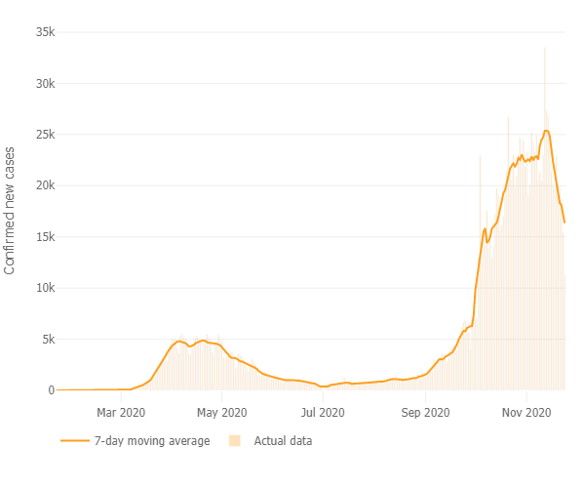

**Mortality by country**

